Theology in the Pub

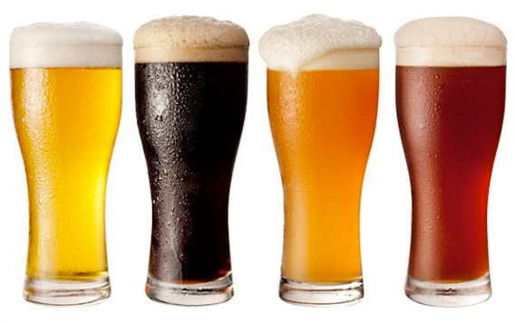

All are welcome to this informal but in-depth theology discussion group

2nd and 4th Tuesday of each month, 8pm

Autumn Programme 2018

11th September Confession
25th September The book of Timothy
9th October The life of Julian of Norwich
23rd October Heresies in the Early Church
13th November Remembrance and the Church
27th November Christ the King

The Old Eagle
Royal College St
NW1 9LU
posp.co.uk

